Table Of Contents

1
1.1 Introduction 1
1.1.1 Course Overview 1
1.1.2 What Is A Forklift? 1
1.1.4 High Risk Work And WHS Legislation 2
1.1.6 High Risk Work Licenses 2
1.2 Plan Work 2
1.3.2 Risk/Hazard Identification 3
1.4 Forklift Trucks 5
1.4.1 Counterbalanced Forklifts 6
1.4.3.3 Load Centre Distance 7
2.1.5 Safety Devices 8
2.5.1.1 Calculating Load Weight 8

1.1 Introduction

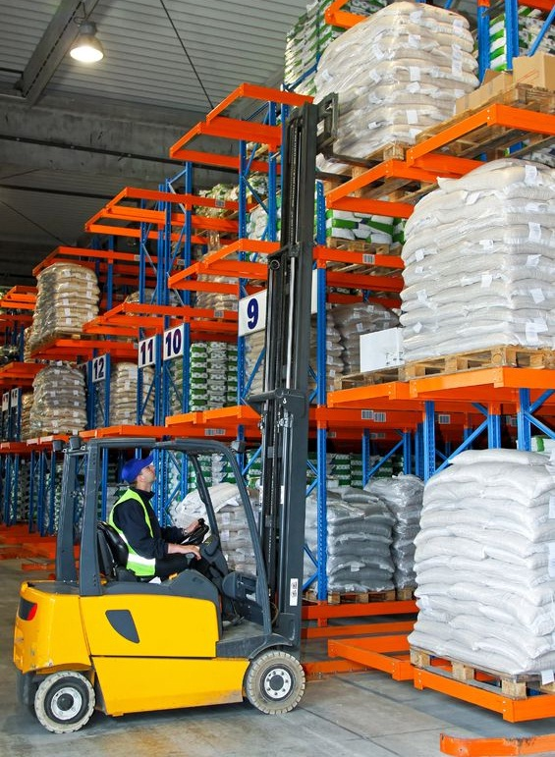
This training course is based on the National High Risk Licence Unit of Competence TLILIC0003: Licence to operate a forklift truck.

Safe Work Australia, along with state regulators (for example, WorkSafe Victoria), aim to facilitate the operation of a nationally uniform, competency-based licensing system for persons performing certain types of high-risk work.

The National Standard recognises the importance of quality training as an underpinning principle in providing skilled workers, and that the most effective form of training is a combination of informal and formal training methods. It requires training and assessment to be undertaken by a Registered Training Organisation (RTO).

1.1.1 Course Overview

Throughout this unit you will learn about:
- Planning out your work.
- Conducting routine checks on the forklift.
- Shifting loads safely.
- Shutting down and securing the forklift after use.

1.1.2 What Is A Forklift?

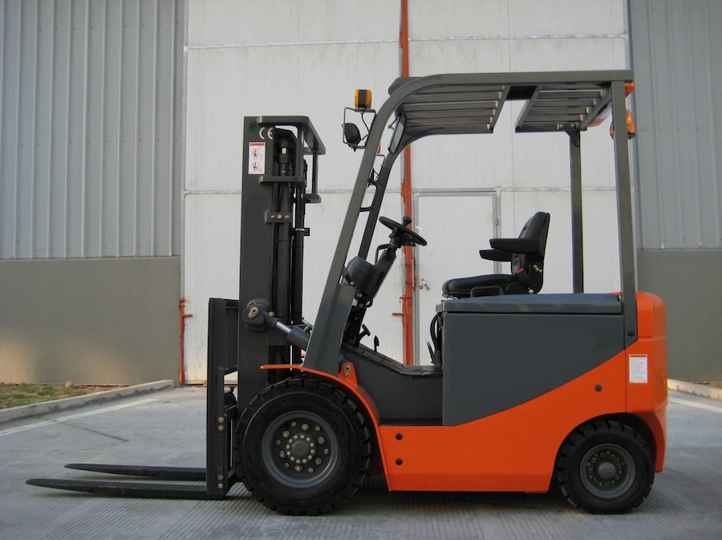
A forklift is a powered industrial truck equipped with a mast and an elevating load carriage to which is attached a pair of fork arms or another attachment.

This can also include trucks on which the operator is raised with the attachment for order picking.

1.1.4 High Risk Work And WHS Legislation

Under the WHS regulations a trainee is defined as a person who is enrolled in a course of HRW training, and being supervised at a workplace (direct supervision) by a person with a current HRW licence for the work.

As a trainee you are learning (either on the job or in a simulated classroom environment) everything you need to know to ensure that you are going to be working safely and efficiently.

Once you have completed your training and have been assessed, you will be able to make your application for a high risk work licence. The application for a HRW licence must be made within 60 days of receiving a notice of satisfactory assessment issued by an assessor.

1.1.6 High Risk Work Licenses

The holder of a HRW licence is responsible for taking reasonable precautions and exercising proper diligence in performing the high risk work.

Failing to work safely when performing high risk work can lead to the licence holder being penalised under WHS regulations. If you fail to work safely, the regulator (e.g. WorkSafe Victoria) may:
- Suspend your licence
- Cancel your licence
- Refuse to renew your licence (if the matter is raised at the time of renewal).
- Directly reassess you to determine your competency
- Prosecute you

1.2 Plan Work

It is important that you are aware of the requirements relating to your work. Before you begin your tasks ensure that you access the relevant documentation and plan your work; to ensure work is carried out safely & in line with the work requirements.

Requirements relating to your work may include:
- OHS/WHS requirements.
- Duty of care.
- Safe work practices.
- Safe Work Method Statements.
Sources of OHS information (types of WHS/OHS legislation, requirements and guidelines) may include, but is not limited to, the following:
- OHS Acts
- OHS Regulations
- Australian Standards
- Codes of Practice/Compliance Codes
- Management plans
- Workplace OHS policy and procedures
- Manufacturer’s instructions
- Logbook
- Forklift Data Plate
- Operations manual
- WorkSafe website
- Safety notice boards
- Workplace risk assessment records

1.3.2 Risk/Hazard Identification

Common workplace hazards include:

- Ground conditions:  - Damaged or cracked bitumen & concrete: May damage tyres and cause instability of the forklift  - Slopes, ramps and inclines.  - Underground services.  - Non-weight bearing surfaces.  - Water or ice impacted ground  - Railway tracks  - Steel decks or grates  - Potholes  - Compacted soil: May not support the weight of the forklift and the ground can be unpredictable  - Backfilled ground: can be unpredictable; unstable ground; risks of serious injury  AT EYE LEVEL | - Overhead hazards:  - Electrical power lines.  - Overhead service lines.  - Bridges.  - Roof beams  - Doorways | - Poor lighting.  - Weather:  - Wet and/or slippery conditions  - Strong winds  - Exposure to sun and heat - Ultraviolet (UV) exposure  - Smoke  - Limited visibility  - Snow and/or ice  - Forklift instability:  - Overloading.  - Poor load placement.  - Irregular loads.
- Surrounding structures:  - Buildings.  - Obstructions.  - Pallet racking. | - Traffic:  - Pedestrians.  - Vehicles.  - Other plant. | - Other hazards  - Dangerous materials  - Restricted & poorly ventilated areas  - Rubbish  - Trees  - Shrubs
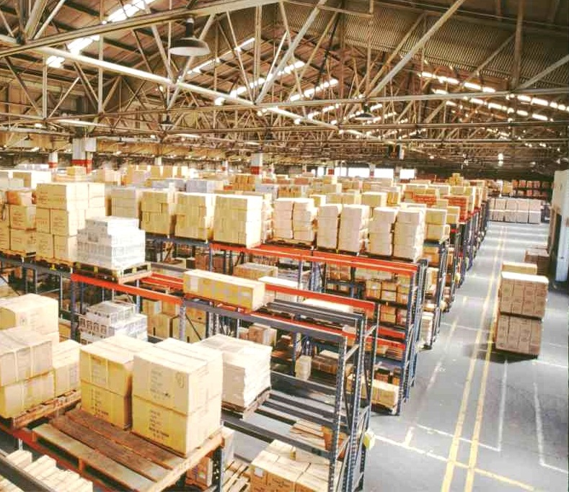
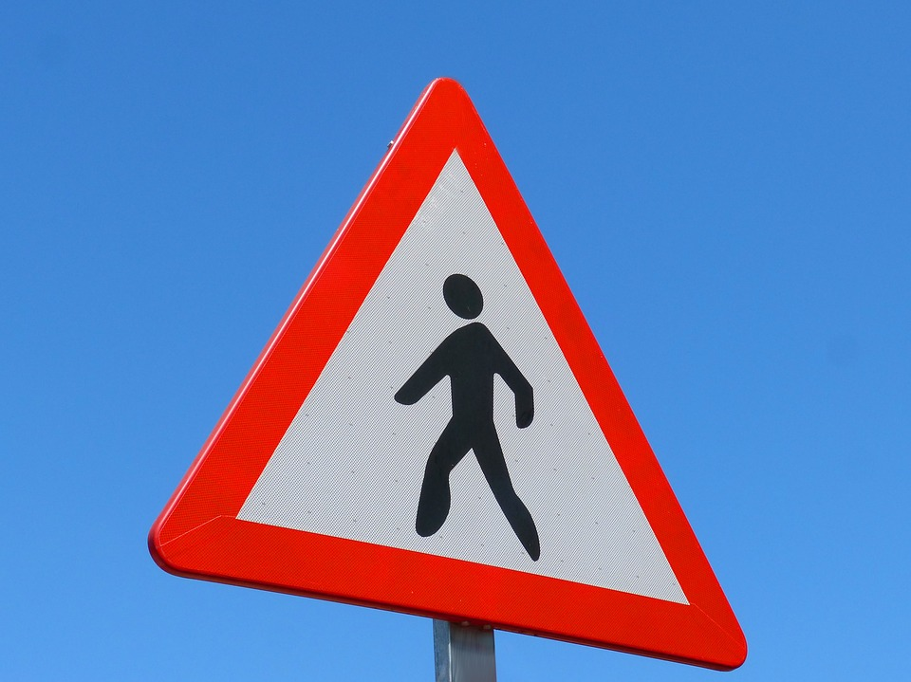

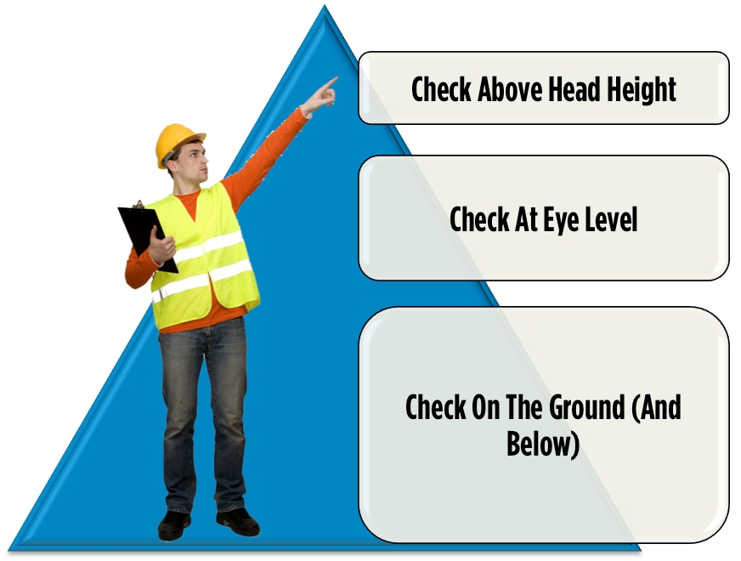
Part of your job is to look around to see if you can find any hazards before you start using the forklift.

A good tip is to check:
- Above head height – remember the forklift can reach much higher than you can!
- At eye level – look around to see if there is anything in the way of where you want to drive the forklift.
- On the ground (and below) – humps and bumps, slippery surfaces and rubbish can all be dangerous. Also make sure that any ramps or flooring can take the weight of the forklift.

1.4 Forklift Trucks

Selecting the correct equipment for the job is very important.

Before starting the job you will need to think about:
- The ground conditions.
- The work areas ventilation.
- How much room you have to work in.
- The type of load.

These factors will influence your choice of forklift truck and attachments.

There are a few kinds of forklift trucks that you might use. These include:

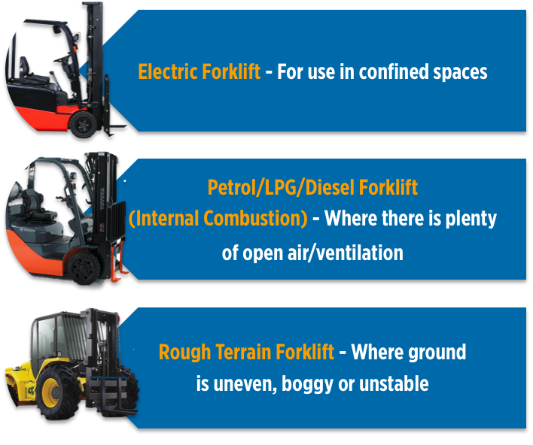

Each type of forklift has its strengths and limitations. The type of work you are doing will determine the best kind of forklift to use.

People could be overcome by (overwhelmed or pass out) by toxic fumes if you drive an internal combustion engine (LPG/Diesel/Petrol forklift) in a restricted space/confined space. Forklifts powered by a battery (electric) or hydrogen forklifts are the best forklifts to use in restricted spaces or confined spaces.


DO NOT use an internal combustion forklift in a confined (small/restricted) space (e.g. container, cool room).
The toxic fumes could kill!

1.4.1 Counterbalanced Forklifts

Counterbalanced forklifts are among the most common types of forklift truck.

These forklifts use the entire weight of the forklift (behind the point of balance) as a counterweight to the weight of the load.

By using the entire weight of the forklift, a load can be lifted safely without tipping the forklift forwards.

The point of balance is where the front tyre touches the ground. Everything behind the front axle of the forklift is used to counter the weight of the load that is being lifted.

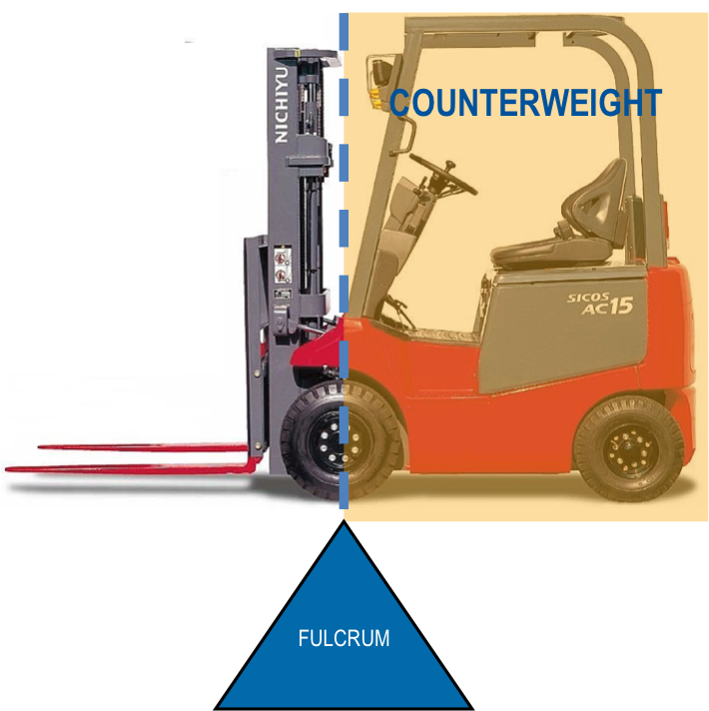

Never add additional counterweights to the forklift truck without referring to the forklift manufacturer first.

1.4.3.3 Load Centre Distance

The distances from the front face of the forks (or the load face of an attachment) to the centre gravity of the load called the Load Centre Distance.
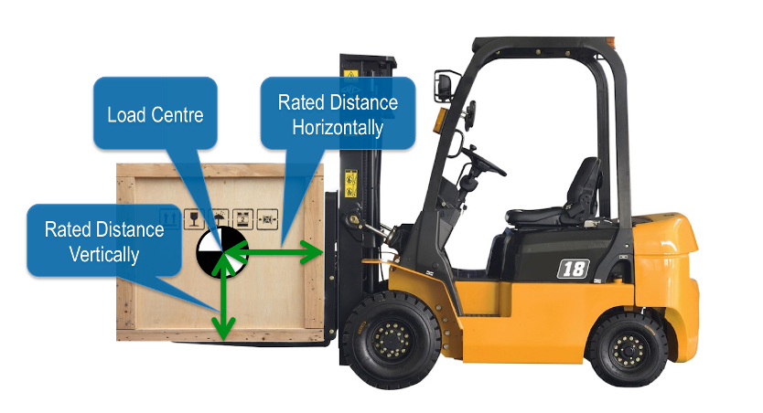
The use of special attachments instead of forks will also have an effect on the regular capacity of the forklift truck.
Adding attachments can increase the load centre distance, therefore the forklift’s load capacity decreases.

If the load is not hard up against the heel of the fork arms, the forklift truck’s capacity is reduced and stability may also be affected.
The forklift trucks shown here are rated at 4200kg at 600mm load centre:

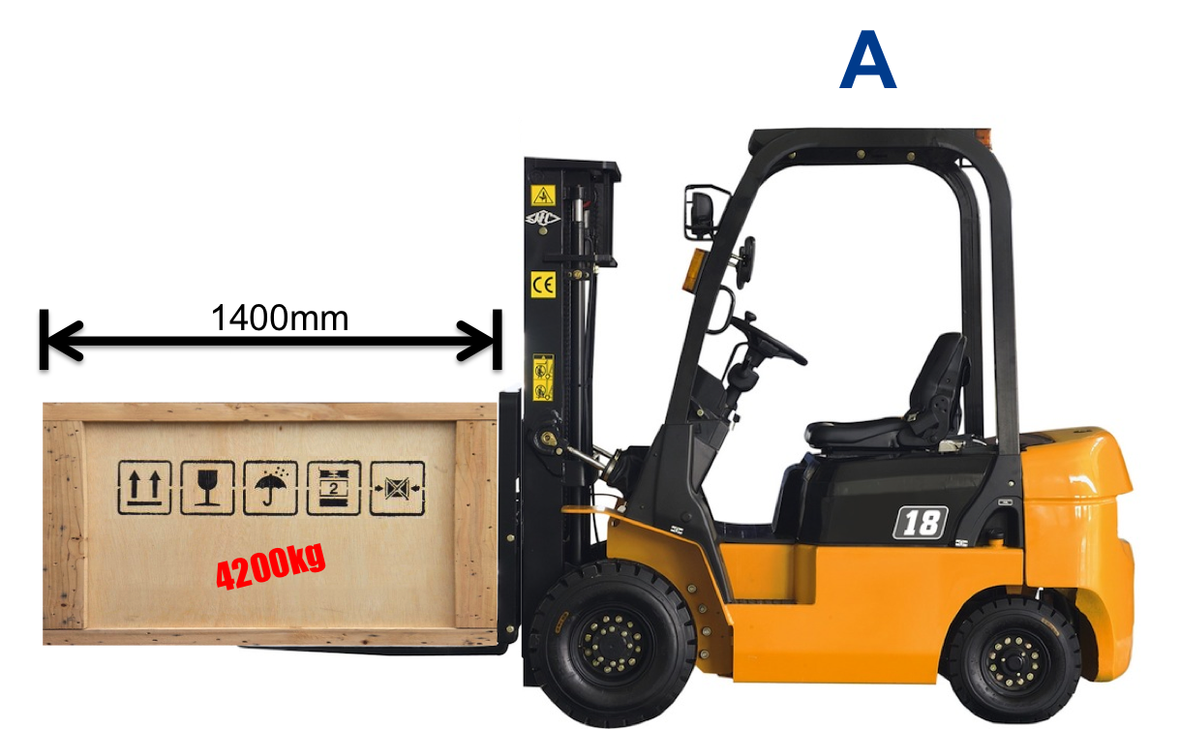 | 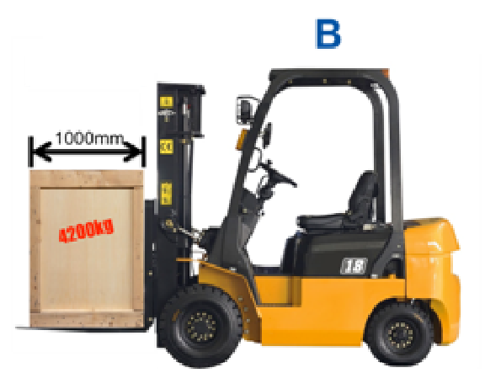
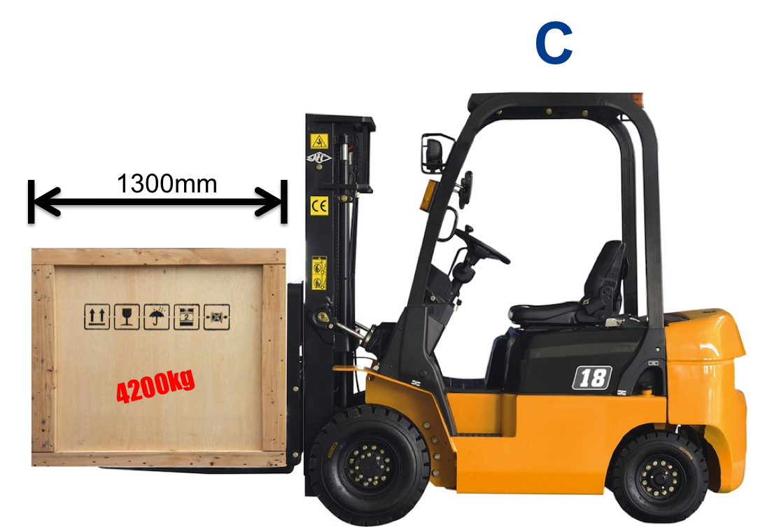 | Of these forklifts, only forklift B has a load that is within the rated capacity of the forklift:  The load centre distance for forklift B is 500mm (within the 600mm limit for 4200kg). Forklifts A and C have a load centre distance of 700mm and 650mm (beyond the 600mm limit).

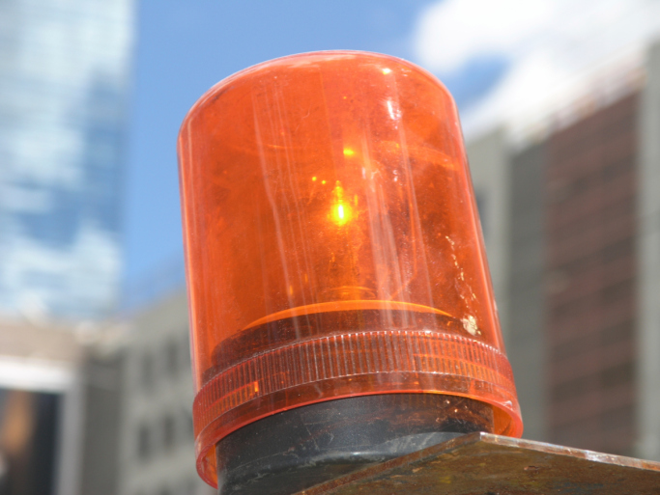

2.1.5 Safety Devices

Check that the forklift has the appropriate safety devices fitted. These can include:
- Lights:
- Flashing amber light.
- Head lights.
- Brake lights.
- Reverse lights.
- Guards:
- Roll-Over Protection (ROP)/Roll bar - Protects the operator in the event of a roll over.
- Falling Object Protection (FOP) / Overhead guard - Protects the operator from falling objects.
- Load guard or Load backrest - Stops the load hitting the mast and protects the
Operator from loads falling backwards when the mast is raised.
- Foot guard - Protects the operators feet.

- Mirrors- Check these are secure & clean
- Seat & seat belt
  - Seat is secured & seat belt engages & disengages ok

2.5.1.1 Calculating Load Weight

If you find you need to calculate the weight of a load, make sure you consider:
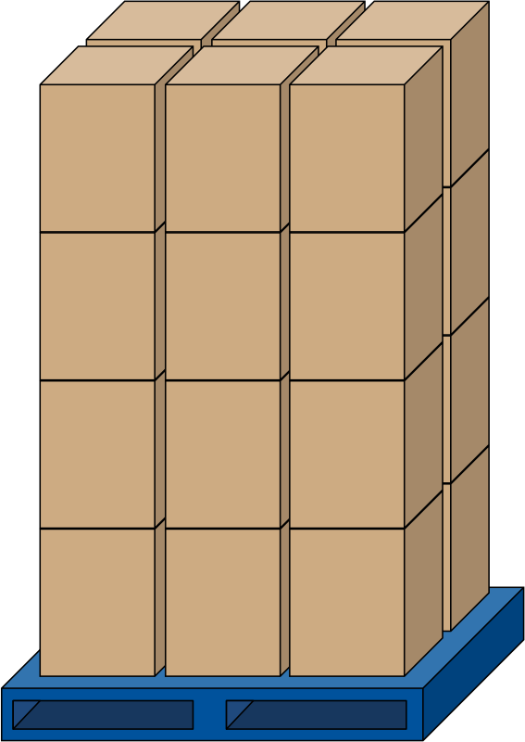
- How many items there are
- What each item weighs.
- The weight of the pallet the items are placed on.

For example:

You need to move a load of cartons that have been stacked on a pallet.
- There are 6 cartons per layer and 4 layers on the pallet.
- Each carton weighs 33kg.
- The pallet is standard size and weighs 15kg.

To work out how much this load weighs you need to add the total weight of all of the cartons to the weight of the pallet:

33kg x 6 x 4 = 792kg

792kg + 15kg = 807kg

