PART A – WRITTEN QUESTIONS
- If a person is enrolled in a course for HRW training, who must they be supervised by? (Circle the correct answer). [Learner Guide Section: 1.1.4]
- Their boss
- Their work colleagues
- Direct supervision by someone with a HRW licence
- Nobody, if they have been properly instructed on how to operate a forklift

- If you successfully pass this course, how many days do you have to get to submit your application for a high-risk work licence to the relevant authority? (Circle the correct answer) [Learner Guide Section: 1.1.4]
- 30 days
- 45 days
- 60 days
- 75 days

- What can the regulator (i.e. WorkSafe Victoria) do if you fail to work safely? List five (5) things. [Learner Guide Section: 1.1.6]
  - ____________________________________________________________________
  - ____________________________________________________________________
  - ____________________________________________________________________
  - ____________________________________________________________________
  - ____________________________________________________________________
- List the six (6) main types of WHS/OHS legislation, requirements and guidelines (which are sources of OHS information). [Learner Guide Section: 1.2]
  - ____________________________________________________________________
  - ____________________________________________________________________
  - ____________________________________________________________________
  - ____________________________________________________________________
  - ____________________________________________________________________
  - ____________________________________________________________________

- List twelve (12) common workplace hazards relevant to your work as a forklift operator under the following headings. [Learner Guide Section: 1.3.2]
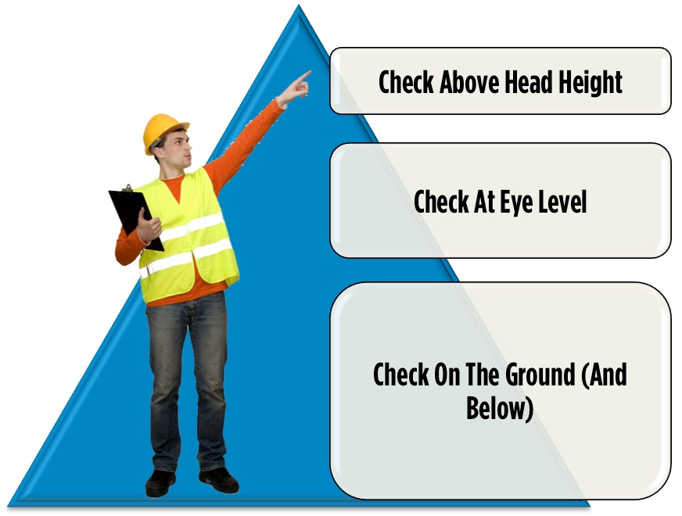
Overhead hazards: List four (4)  1. ……………………………………………………  2. ……………………………………………………  3. ……………………………………………………  4. …………………………………………………… | At eye level: List four (4)  1. ……………………………………………………  2. ……………………………………………………  3. ……………………………………………………  4. ……………………………………………………
On the ground and below: List four (4)

1. ……………………………………………………

2. ……………………………………………………

3. ……………………………………………………

4. ……………………………………………………

- Which is the best forklift to use in restricted spaces or confined spaces?
[Learner Guide Section 1.4]
___________________________________________________________________________

- Show the point of balance (fulcrum) on a forklift in the diagram below: [Learner Guide Section 1.4.1]
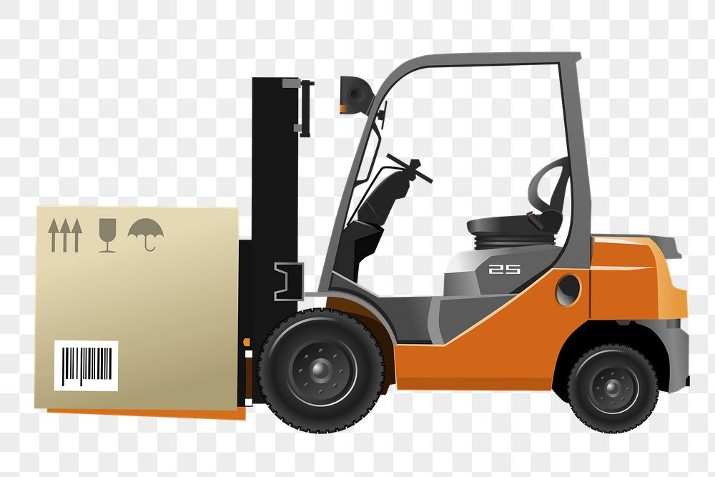

- How is the forklift operation affected if the load is not hard against the heel of the fork arms? List two (2) impacts. [Learner Guide Section 1.4.3.3]
  - ____________________________________________________________________
  - ____________________________________________________________________

- Identify the use of the following four (4) guards that are fitted to a forklift. Complete the following table [Learner Guide Section: 2.1.5]
Guard name | Use
Load guard/load backrest
Rollover protective structures (ROPS)/Roll bar
Falling object protective structure (FOPS)/ Overhead guard
Foot guard

PART B – CALCULATIONs QUESTIONS

Answer the following calculation questions using a calculator. Show how you worked out the answer.

- On a pallet weighing 15kg there is:
10 cartons weighing 12 kg each
2 drums weighing 22kg each
What is the total weight of the load? [Learner Guide Section 2.5.1.1]

- On a standard size Australian pallet weighing 35kg there are 3 electric motors weighing 395kg each. What is the total weight of the load? [Learner Guide Section 2.5.1.1]

…………………………………………………………………………………………………………………………………………………

