Table of Contents
1.1 Introduction 2
1.1.3 High Risk Work Licence Requirements 2
1.2.2 Duty of Care 2
1.5.1 Identify Hazards 3
2.1.1 Determine the Weight of the Load 3
2.2.3.2 Crane Capacity Calculations 4
2.3.2 Visual Checks 7
2.7 Check Crane Safety Devices 8
2.7.1 Safety Devices 8
Appendix B – Crane Specifications – Tower Crane 9

1.1 Introduction

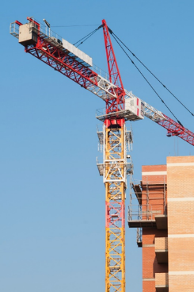
This training course is based on the National High Risk Licence Unit of Competency CPCCLTC4001 Licence to operate a tower crane.


1.1.3 High Risk Work Licence Requirements

Once you pass your assessment, you will have 60 days to apply for your licence.

You can still do high risk work without a licence as long as:
- You are enrolled in a high risk course for the class, and
- You are being supervised by somebody who has a current valid licence for the same high-risk work licence class.

 | As part of their legal duty of care, licensed workers must take reasonable steps to make sure the way they work does not impact on the safety of themselves or any others on site. Failing to work safely can result in the health and safety regulator:  - Suspending your licence.  - Cancelling your licence.  - Refusing to renew your licence.  - Ordering that you are reassessed to ensure you are competent.  - Taking legal action to prosecute.

1.2.2 Duty of Care

Responsibilities of an employer to ensure the health and safety of employees in the workplace (i.e. actions an employer should take to ensure health and safety of workers): To meet their duty of care obligations an employer is required to:

- Provide and maintain a safe workplace.
- Provide and maintain safe plant, structures and equipment (including basic firefighting equipment, First Aid equipment).
- Provide and maintain safe systems/procedures for work (e.g. emergency procedures, housekeeping to ensure a clean, tidy and safe work area, measures to prevent bullying and harassment, safe waste disposal areas).
- Provide facilities that are adequate for the employees and others on site (site amenities, such as drinking water and toilets.)
- Provide instruction, training, supervision and information for work to be undertaken safely, including any time you are required to use unfamiliar or new equipment.
- Take action or make arrangements to ensure all equipment, structures, plant and substances used on site are handled and stored in a safe way.
They must also ensure that everyone has received adequate training, information, or supervision to complete their work. This includes providing sufficient information, training, instruction and/or supervision to individuals who have recently completed their High Risk Work Licence and are going to be completing unfamiliar tower crane work, i.e.:

- Information about the crane.
- Training about crane operations.
- Supervision.
- Instruction about crane safety considerations.

1.5.1 Identify Hazards

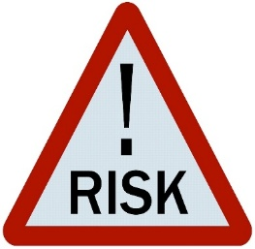
Part of your job is to look around to see if you can find any hazards before you start any work.

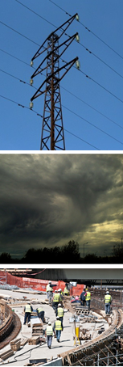
Some common hazards related to tower crane operations include:

- Overhead hazards:
  - Power lines.
  - Overhead service lines.
  - Obstructions.
  - Trees.
  - Bridges.
  - Tall structures and buildings.

- Ground conditions:
  - Underground services.
  - Potential non-weight bearing surfaces.
- Weather:
  - Lightning.
  - Storms.
  - Heavy wind.
- Insufficient lighting/lack of illumination.
- Traffic:
  - Pedestrians.
  - Vehicles.
- Workplace-specific hazards:
  - Other workers.
  - Plant and equipment including other cranes and booms in the area.
- Surrounding structures:
  - Buildings.
  - Obstructions.
  - Facilities.
- Working at heights (access and egress to the crane cabin).
- Dangerous materials including combustible substances (fuel).

2.1.1 Determine the Weight of the Load

A licensed Dogman or Rigger is responsible for performing the following tasks:


- Determining the weight of a load.
- Communicating the weight of the load to the crane operator.
- Legally slinging a load.
- Directing a crane.
- Identifying lifting points and lifting methods.
- Selecting and inspecting rigging gear.
- Putting a load in a crane hook.
The crane operator needs to communicate with the person slinging the load and give them appropriate information such as the capacity of the crane that is to be used. The crane operator is responsible for ensuring the load being lifted is within the capacity of the crane.

Before lifting with a tower crane, you should consider the following factors to make sure the lift and crane operations do not exceed the crane’s rated capacity:

- Weight of the load
- Operating radius
It is extremely dangerous to attempt to lift a load of unknown weight – you could cause structural damage to the crane and damage to the lifting gear and load.

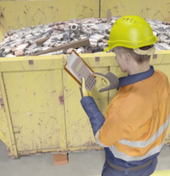
You can determine the weight of a load a number of ways. These include:
- Estimating the weight of the load by calculations.
- The weight may be marked on consignment or weighbridge notes. Obtain and check these notes.
- Consulting with a dogger/rigger.
- Weighing the load.
- Checking the load itself. The weight may be marked on the load or the packaging it arrives in.

2.2.3.2 Crane Capacity Calculations


It is important that you are able to calculate the capacity of different crane configurations using information found in the load chart.

The following are examples of how to use crane specifications using the “Crane Specifications – Tower Crane” that can be found in Appendix B.

Each crane has a set of documents that outline its unique specifications. The “Crane Specifications – Tower Crane” is being used for these examples and should not be used for any other purpose.

Example 1 – Maximum Load to be Lifted (based on Operating Radius)

Use the “Crane Specifications – Tower Crane” found in Appendix B to work out the maximum load that can be lifted using the following configuration:

Crane Configuration
Main Boom Length | 50m
Operating Radius | 34.0m

Step 1 – Ensure the Load Chart Section is Applicable

The first step in finding the maximum load that this configuration can lift is to consult the crane specifications and ensure that the information available is relevant for this configuration.

To do this we must ensure that the information is for a Main Boom Length of 50m.
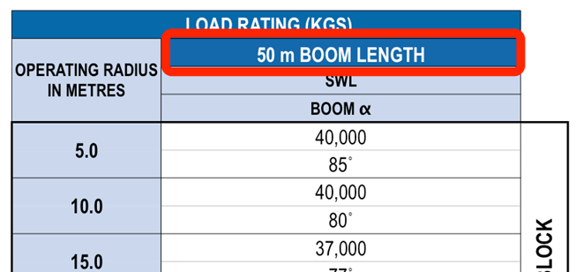
Step 2 – Determine the Rated Capacity for the Configuration

The second step in working out the maximum load involves using the chart to find the rated capacity that corresponds to the main boom length.
Follow the “Operating Radius in Metres” column down until you find 34.0m.

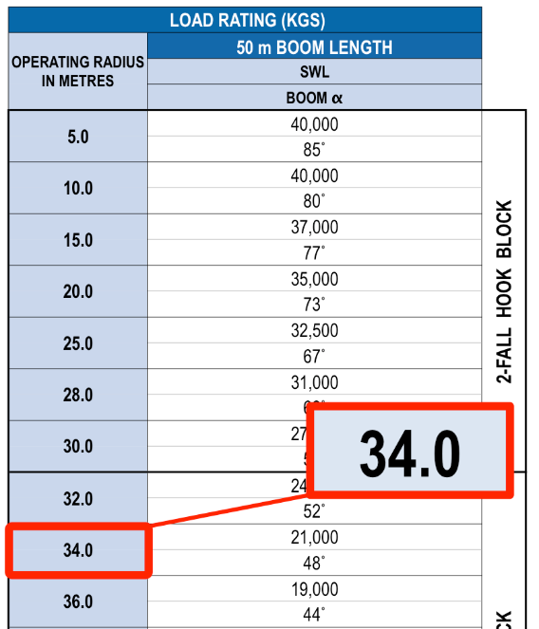

The corresponding Rated Capacity (sometimes called the Safe Working Load (SWL)) is the maximum load that can be lifted using this configuration.

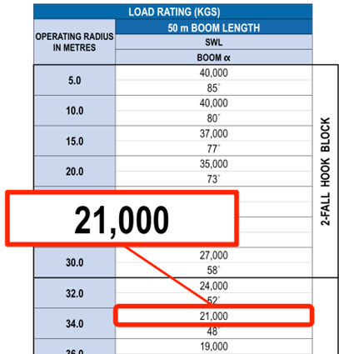

Therefore, the maximum load that can be lifted for this configuration is 21000kg (or 21 tonnes).

Example 2 – Maximum Operating Radius (based on Boom Angle)

Use the “Crane Specifications – Tower Crane” found in Appendix B to determine the maximum operating radius that can be used for the following configuration:

Crane Configuration
Main Boom Length | 50m
Boom Angle | 77˚

Step 1 – Ensure the Load Chart Section is Applicable

The first step in finding the maximum operating radius that this configuration can use is to consult the crane specifications and ensure that the information available is relevant to the configuration.

For this configuration you must ensure that the Main Boom Length is correct (in this case 50m).

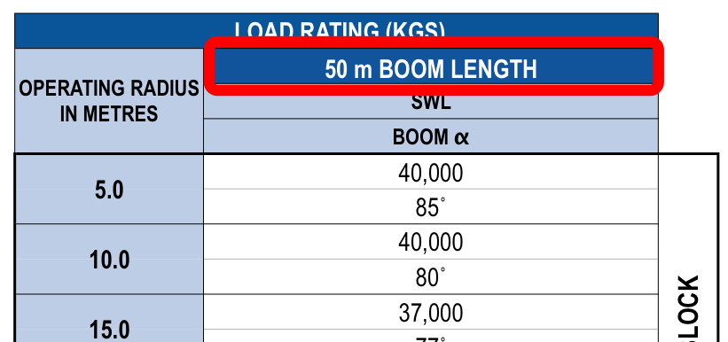

Step 2 – Determine the Rated Capacity for the Configuration

After confirming the chart is relevant the second step in working out the operating radius involves using the chart to find the relevant boom angle for the configuration.

For this configuration the required boom angle is 77˚.

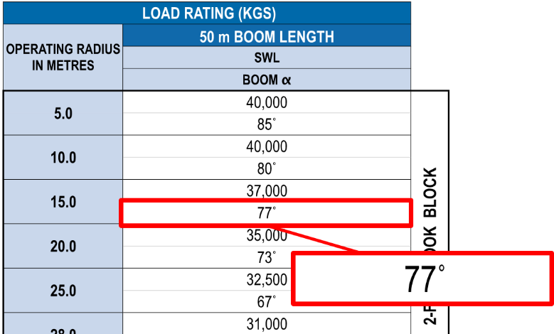

The maximum operating radius for this configuration is found in the corresponding “Operating Radius in Metres” column.

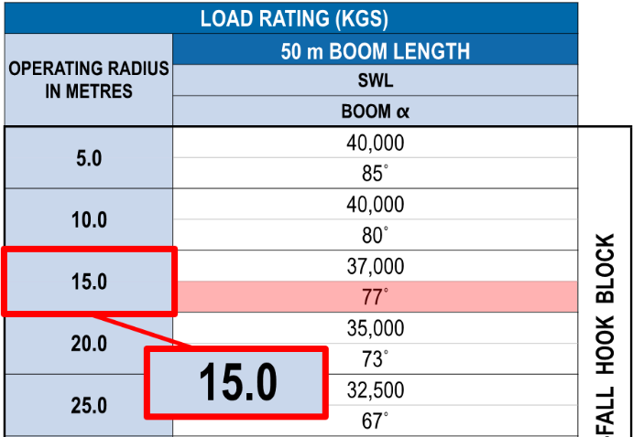

Therefore, the maximum operating radius for this configuration is 15.0m.

Hoist Speeds


Tower cranes may also be rated by hoist speeds. For example a crane may be rated at 18 tonnes in low speed but only 9 tonnes at high speed.

If you are required to shift from low speed to high speed you will need to make sure that the load on the hook does not exceed the high speed hoisting capacity – overloading could cause hoist or motor damage.

Where hooks with multiple parts of line are used (e.g. 2-fall or 4-fall hook blocks) there may be a note on the crane chart that specifies that the crane must not be operated past a particular radius.

This is because the total weight of the load is being divided between the hoist mechanism and the hydraulic luffing rams. Any overloading could cause damage or structural collapse of the rams.

2.3.2 Visual Checks

 | Walk around the crane and carry out a visual inspection for signs of any defects on the boom or superstructure. The following things could indicate the tower crane has structural defects:  - Cracks in the boom, superstructure or welds.  - Bends and/or twists in the boom or superstructure.  - Rust from welds or joints.  - Flaking paint.  - Loose or missing bolts.  - Bent pins.  - Cut lacings.  - Oil leaks.

You will also need to check the condition of access ladders and kick plates and make sure that access to the cabin is unobstructed.

2.7 Check Crane Safety Devices

After starting the crane, you will need to check that all safety devices are working properly.

2.7.1 Safety Devices

Types of safety devices commonly installed on tower cranes include:
- Audible and visual alarms
- Aviation lights
- Illumination for low-light operations
- Motion limits
- Overload limits
- Anti-collision devices
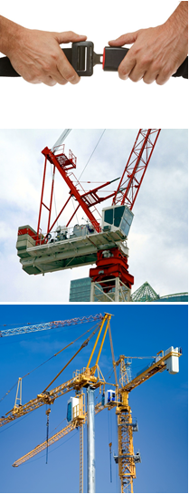
Check all safety devices on the crane including:
- Operator restraint devices.
- Lights including aviation lights.
- Testing the maximum radius limit.
- Testing the minimum radius limit.
- Audible and visual devices.
- Testing the hoist limit – This will ensure the limit or cut-out switch is operational or working properly to prevent damage to the rope (leading to the loss of the hook and load) and two-blocking/double blocking (where the hook block comes into contact with the head sheaves of the boom or trolley).
- Testing all warning systems/devices for correct operation.
- Testing the emergency stop switch.
- Testing the anti-cavitation device – Cavitation occurs when the pumps are demanding hydraulic oil faster than it can be supplied and the pumps suck air into the hydraulic system instead, resulting in a ‘free-fall’.
- The anti-cavitation device senses this and applies the brakes.
- You can test the anti-cavitation device by using a small pressure line that simulates cavitation.
- You should hear an air release and the brakes will be applied with the controls returning to neutral.
- The load mass indicator should be calibrated every six months (or in accordance with the manufacturer’s specifications).
- You can test the accuracy of the load mass indicator by selecting a load that you already know the weight of, lifting it and testing the result on the indicator against the known weight of the load.

Appendix B – Crane Specifications – Tower Crane

