PART A – WRITTEN QUESTIONS

- If a person is enrolled in a course for HRW training, who must they be supervised by? [Learner Guide Section: 1.1.3]
___________________________________________________________________________
- What can the regulator do if you fail to work safely? List three (3) things.
[Learner Guide Section: 1.1.3]
  - ____________________________________________________________________
  - ____________________________________________________________________
  - ____________________________________________________________________

- List four (4) responsibilities of an employer to ensure the health and safety of employees in the workplace (i.e. actions an employer should take to ensure health and safety of workers). [Learner Guide Section: 1.2.2]
  - _____________________________________________________________________
  - ____________________________________________________________________
  - ____________________________________________________________________
  - ____________________________________________________________________
- You have successfully obtained your CT Licence, and your employer purchases a new tower crane. List three (3) things your employer must provide you with before you use the new crane.
[Learner Guide Section: 1.2.2
  - ____________________________________________________________________
  - ____________________________________________________________________
  - ____________________________________________________________________

- List twelve (12) common workplace hazards relevant to your work as a tower crane operator under the following headings. [Learner Guide Section: 1.5.1]
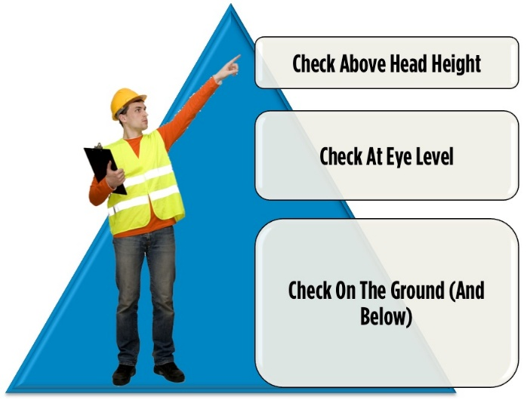 | Overhead hazards: List four (4)  1)___________________________  2) ___________________________  3) ___________________________  4) ___________________________
At eye level: List four (4)
1)___________________________

2) ___________________________

3) ___________________________

4) ___________________________
On the ground or below; and other hazards: List four (4)
1)___________________________

2) ___________________________

3) ___________________________

4) ___________________________

- Before lifting with a tower crane, name two (2) things you should consider to make sure the lift and crane operations do not exceed the crane’s rated capacity. [Learner Guide Section 2.1.1]
  - ____________________________________________________________________
  - ____________________________________________________________________
- List five (5) things that could indicate the tower crane has structural defects. [Learner Guide Section: 2.3.2]
  - ____________________________________________________________________
  - ____________________________________________________________________
  - ____________________________________________________________________
  - ____________________________________________________________________
  - ____________________________________________________________________

- Identify six (6) types of safety devices commonly installed on tower cranes. [Learner Guide Section: 2.7.1]
  - ____________________________________________________________________
  - ____________________________________________________________________
  - ____________________________________________________________________
  - ____________________________________________________________________
  - ____________________________________________________________________
  - ____________________________________________________________________

- Why should the hoist limit or cut-out switch on a crane be checked? [Learner Guide Section: 2.7.1]
___________________________________________________________________

Check out the Crane Capacity Calculation section in the learner guide (Section 2.2.3.2) and the Crane Specifications – Tower Crane in Appendix B. You will be taught this in class, with access to a range of tower crane load charts and related calculations.

